

7:30 – 7:35 - Citizen Comments

7:35 Government Study Committee – Article Discussion

New Business

- 2011 Junk Collectors License Renewals

- Discuss Creation of Economic Development Committee

- Budget Discussion

- Town Meeting Article Discussion

Road Openings

- Request from Columbia Gas for maintenance and corrosion control at Pine Street and Green Street. A 2’ x 2’+ road cut is needed. Dig Safe # 20111408588.

Announcements

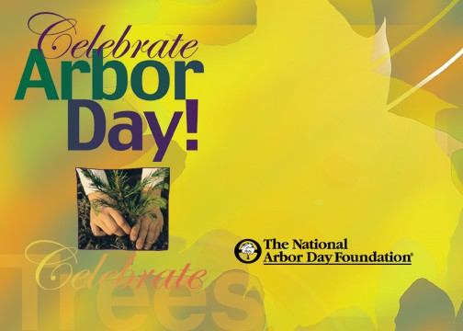
Executive Session

